Jeffery Crosby
3-10-12
Sue Briggs
ENGL 2010; T, TH 10:00-11:15
Conservation of the Big Cats

Earth is one really big planet, seventy percent water and the other thirty is the land of the seven continents which are structured by many countries. Each one is very special and unique in its own way with their amazing wonders. Australia houses the Great Barrier Reef, China for the Great Wall, Brazil has the Amazon, Egypt possesses the Pyramids of Giza, and Greece is home to the Pantheon. These magnificent wonders are just a portion of what makes each country they’re located in a beauty to behold; there are also mountains, deserts, lakes, forests, and much more. Although, scenery in any place no matter where isn’t complete without life forms that aren’t exactly humans but what are they?
The answer is animals! Animals have occupied the planet for thousands of years and are an important aspect for they help keep it in balance and give it beauty. They also give a huge amount of amusement to people around the world with the hundreds of known species alive today such as lizards, frogs, and birds. There’s just one problem today that threatens their existence which is that they’re becoming endangered! One group of animals that’s in really danger of becoming extinct within the next twenty years is the “big cats.” Big cats are part of the Felidae family which includes jaguars, tigers, and cheetahs which are vanishing all due to causes like hunting, poaching, habitat destruction, and more. These problems have become serious that it’s come to where action needs to be taken to try to conserve all the members of the cat family so they won’t disappear and can continue to be enjoyed.
South America, the continent located south of North America, is a place that’s known to possess the world’s largest rainforest, the Amazon. It covers forty percent of South America which would be enough to cover forty-eight of the states in the U.S. The Amazon is also a great source of producing Earths oxygen and even supplies about twenty percent of its fresh water. But the one thing that the rainforest is most famous for is its abundance of wildlife; such as toucans, frogs, monkeys, etc. giving them an amazing ecosystem to make home. (“Amazon Basin,” par.1, 6) Especially to one carnivorous creature that lurks in its high tree tops for its next meal.
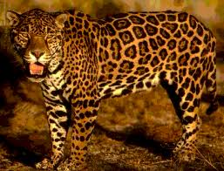
Imagine a monkey just hanging around in the trees when out of the blue an animal with a yellow and black orange spotted fur coat and razor sharp claws, pins it down and then sinks into its prey. Just who is this vicious animal? The answer is a jaguar! Jaguars are big cats that get their name from Native Americans deriving from the word yaguar meaning “he who kills with one leap.” They can live up to fifteen years in the wild and are excellent at swimming which provides them with fish and turtles for prey. These cats are able to give birth to a litter of up to about four cubs which stay with their mother for two years and then make their way into the open wild. (Jaguar 2) If they are able to have so many offspring then why are they disappearing?
Jaguar (panthera onca)

Jaguars are such awesome cats to behold in their natural habitat that when they’re spotted in the trees, lots will leap for joy. The problem though is that people’s joy is decreasing because these cats are currently listed as threatened according to their status. (Jaguar) One reason behind their case is that they are hunted for their fur which is either sold or kept for memory. People say that hunting animals helps keep species under control but the concern with this is that hunters are killing way too many exotic creatures for their own amusement, which, they should only be allowed to do this at least once a year so to let wildlife thrive. Another cause behind the jaguar’s threat is that thirty-nine percent of their home range has been developed for farming which means the trees they live in are being cut down. (Vergano, par.8) The whole entire Amazon is one glorious place but to cut down its home for agriculture isn’t necessary because plants help provide the oxygen for animals to breath and give them a home which needs to be sent out as a message to everybody around the world. Next to jaguars though, they aren’t as nearly endangered as our orange and stripped friend.
Farming in the Amazon
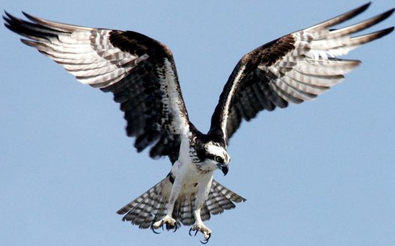
Asia, the biggest continent in the world, is full of culture and heritage with its many different countries. Take for example the Chinese with their cultural celebrations to honor and remember those of the past or even those from India who have a strong belief in gods where they honor them by praying five times a day. Both are outstanding places for everybody to one day visit but besides their cultural beliefs both countries provide great habitats for an assortment creatures such as the Chinese cobra, osprey (India), and Indian porcupine (China). Although, they do share the territory range for one very carnivorous animal that likes to stock prey from behind trees or bushes. This monster has scary glowing yellow eyes, four legs with paws that contain claws of death, and a stripped face that the very sight of it is enough to send shivers through an individual’s entire body.
Osprey (Pandion haliaetus)
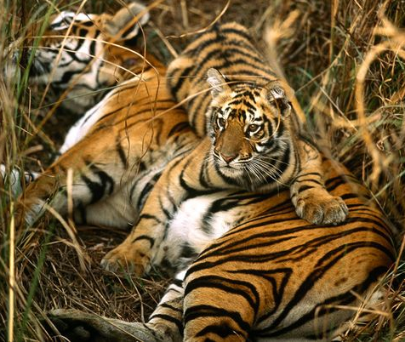
Tigers! One of the most magnificent cats in the world is the largest member of the cat family and known for their strength and power. (Bengal, par.1) Tigers are very territorial creatures that live in large forest areas with big prey (hunt at night) like buffalo and wild pigs. (Tiger, par. 4) (Bengal, Par. 4) In the wild, these cats live from eight to ten years and during that time can have from two to six babies. The cubs usually don’t start hunting until they’re about eighteen months old and then leave her at two or three years old. (Bengal, par.6) These big cats are just enough to make anyone want to take one home cuddle it as a house cat, except, that isn’t possible for they are on the verge of extinction.
Bengal Tiger (Panthera tigris tigris)
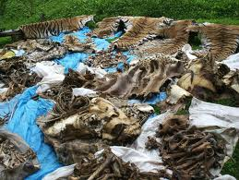
There were once eight species of tiger totaling at a population of fifty thousand. Today however, there are five species of tiger left in the world and are now at a total of three thousand remaining. Their current status marks them as endangered and could eventually go extinct but just what are the reasons why there are so very few tigers left in the wild? One reason behind the decrease in the tiger population is that they are seriously hunted as trophies for their rarity but from this there are programs being set up at wildlife reserves and zoos in hopes of getting tiger’s back into the world. (Bengal, par.2) The most gruesome cause behind their endangerment is that tiger bones are used in Chinese medicine. (Bengal, Par.2) This isn’t right because the world has come so far in the field of medicine; there are other means to produce medication which there should be absolutely no need for animal bones to be used in the process of nurturing someone back to health, the only trouble is distributing them throughout the world to other countries which will one day become a reality. One place that could really use it is the location of the final big cat that lives in a land of dryness and grassy plains.
Tiger Pelts as Trophies
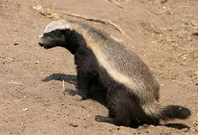
Imagine traveling out in a plane full of tall grass roaming with many lurking surprises with trees presently missing branches and then there’s even a water hole which is being enjoyed by many life forms. Just what exactly is this place of hardship? The answer is the African Savannah, home to hundreds of amazing and outstanding wildlife that have to rely on one another or even their own skills to survive every passing day. Take for example the honey badger that’s helped by a tiny bird to lead it to a beehive where it gets food for not just its self but the bird as well (known as a “symbiotic relationship”). (Honey Seekers) There’s one creature though that has to rely on its ability in order to catch what it needs to survive.
Honey Badger
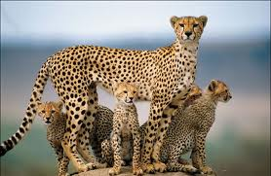
Out in the grass planes of the Savannah is a lone antelope just nibbling away but unknown to it is a figure lurking in the tall grass. This creature is very slim, has a yellow fur coat with black spots, tall legs or running, and excellent eye sight to spot prey but just who is it? The outstanding animal is the incredibly fast and speedy “cheetah!” Cheetahs are known as the fastest land mammals in the world reaching speeds of up to sixty miles an hour which is over in less than a minute resulting in a fast catch for this big cat. These sprinting cats are capable of living up to twelve years in the wild and prefer to feed on any herbivore they can manage to catch such as wildebeest and zebra. A female cheetah is able to have a litter of up to three cubs which watches over them for two years and protects them by giving them commands through chirps. Cheetahs are positively the most magnificent cats to behold to anyone’s eyes but a serious issue threatens their existence.
Cheetah (Acinonyx jubatus)
Just like jaguars and tigers, cheetahs are also among the many big cats that are endangered. Cheetahs right now are listed as “vulnerable” under their protection status and now stand at a total population of about twelve thousand. (Cheetah 2) (Vergano, par.9) These glorious cats are endangered because they are hunted for fur trade but thanks to the United States Endangerment Species Act of 1973, this helped limit the number of cheetah furs being imported. (Wild Cheetah, Par. 1) Another thing being done to preserve cheetahs is that zoos are breeding them to increase their numbers, such as the Wild Animal Park in San Diego. The most critical casualty facing this cat is that Africans are taking away their land which isn’t cool because people aren’t thinking about what they’re doing or taking from an innocent creature and they deserve freedom just as any human on the planet. (Wild Cheetah, par.1)
The Earth is a big place that has much to give it beauty from its oceans, architecture, plants, and most of all is the assortment of animals. The only concern that faces many species today is that they are vanishing (becoming endangered) for many considerable reasons but the one group that could be gone in two decades is the “big cats!” Jaguars dwell in the Amazon and are becoming endangered due to their home being torn down for farming but all that’s going on is their home is being taken for now reason at all. Next are tigers, who reside in parts of Asia, have become seriously endangered all because their bones are used in Chinese medicine but they could get it from other countries around the world which would then result in not so many of these stripped creatures being killed. Finally, the most extraordinary big cat of all is the speedy cheetah which is disappearing due to their territory being taken over by people but they don’t seem to realize the taking of this spotted animal’s freedom. The big cats are such an amazing family of animals that just the sight of one is enough to really make a person fascinated by these predators’ furry designs and the glorious impression they leave in the heart! Take a minute to examine these cats and see what they have to offer, for guarantee; they’ll definitely leave a scratch on life and most likely a chance will come for them to thrive once again!
WORKS CITED
- “Bengal Tiger.” National Geographic. National Geographic Society. N.d. Web. 20 March 2012
- “Cheetah.” National Geographic. National Geographic Society. N.d. Web. 15 March 2012
- “Honey Seekers.” Wild Kratts. KUED. 19 Jan. 2011 Television.
- “Jaguar.” National Geographic. National Geographic Society. N.d. Web. 19 March, 2012
- “THE AMAZON BASIN: Amazing Facts and Figures.” Wcupa.edu. Web. 20 March 2012
- “Tiger Facts.” Smithsonian National Zoological Park. Smithsonian Institution, 1998. Web. 20 March 2012
- Vergano, Dan. “Lions, Tigers, Big Cats May Face Extinction in 20 Years.” USA Today. USA Today, 27 Oct. 2011. Web. 12 March 2012.
- “Wild Cheetahs: A Struggle to Survive.” Animal Planet. Discovery Communication, LLC., 2012. Web. 29 March 2012

